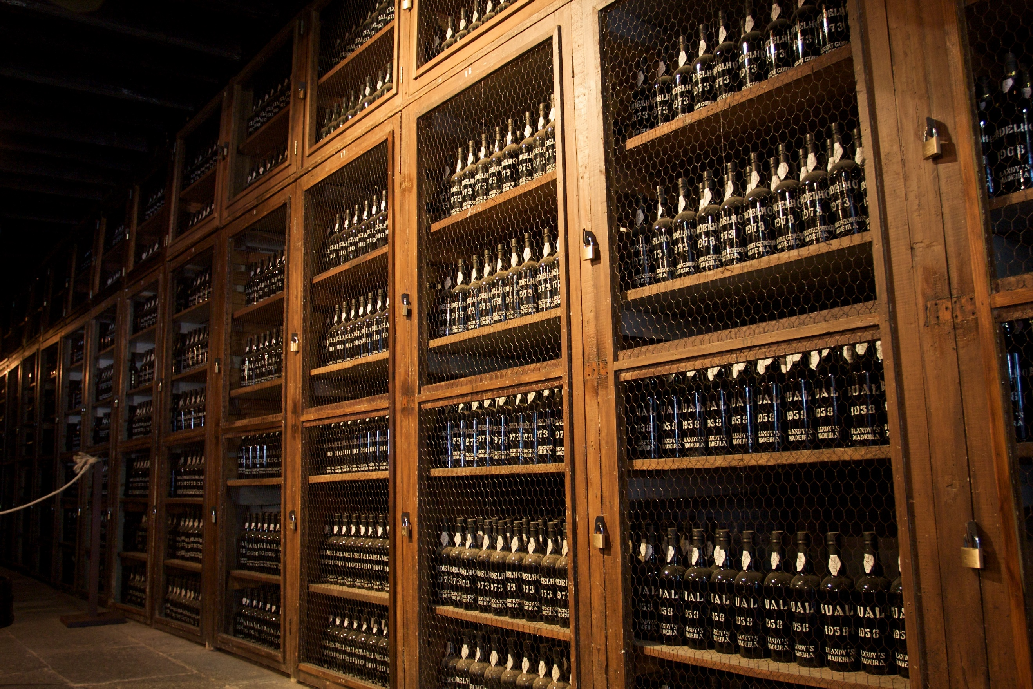  Wine Analysis  September 2019 | Abstract  Is it possible to predict a wine varietal by a description? Is the Sommelier profession in jeopardy? The following paper explores wine descriptions to determine if varietal predictability is feasible.  Ian Aliman, Erin Lore, Brittney Sherman, Jo Vivian  IST707

Introduction
From fancy dinner dates to religious offerings to being good for cardiovascular health, wine is and has been promoted as a staple in many domains for many years. The origin of wine is often debated, however, most agree that wine was discovered versus invented. It is said that the ancient people mistakenly discovered wine when their grapes spoiled and fermented. “The earliest archaeological evidence of wine produced from grapes has been found at sites in China (c. 7000 BC), Georgia (c. 6000 BC), Lebanon (c. 50000 BC), Iran (c. 5000 BC), Greece (c. 4500 BC) and Sicily (c. 4000 BC).” There are many tales told about which of the ancient people first discovered wine. One example is of the Persian Princess. Having heard that she was disliked by the King of Persia, the Princess attempted suicide by consuming a jar of spoiled grapes. Instead of succeeding in her suicide attempt, she found herself feeling better and being happier. Once the King saw her in this state, he liked her new attitude and she was again liked by him.
Regardless of when and where wine originated, it is one of the most consumed alcoholic beverages around the World. In the US alone, 966 gallons are consumed each year. This is up over 200% since the 1970’s. Wine popularity has grown in large parts due to people dining out more, wine availability and the growth of wine tourism. The explosion of wineries in the US has been instrumental in the increase of wine consumption. “In 2019, there were a total of 10,043 wineries in the United States producing wine. Since 2009, the number of wineries in the U.S. has grown by over 50 percent.”
With the increase in the number of wineries, there is certainly no lack of wine varieties. Worldwide, there are over 10,000 types of grapes used in the production of wine. While some welcome the choices, others find deciding on which year, which vineyard and ultimately which wine to select to be an overwhelming process. And why drink wine unless it is going to be an enjoyable experience? Wine can range from tasting like the back of a school bus to quaffable to transcendent. Sadly, not everyone knows how to find that transcendent bottle and how to avoid drinking from what tastes like the back of a school bus. True, if one is visiting an upscale restaurant, a Sommelier, or wine steward, can help. But how does the average person, looking to buy a bottle of wine or two, know which would suit their taste preferences and which may go best with a certain cuisine?
The following analysis explores various wine reviews to determine if predicting wine varietals from a description is feasible. This ability could open the door for wine distributors to reach additional consumers, perhaps those that are not connoisseurs of their beverages.

About the Data
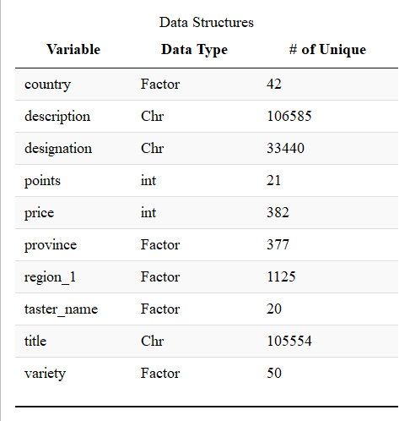
The data set, obtained through Kaggle, includes reviews by several tasters on various wines. The original dataset contains ~130,000 wine reviews with fourteen variables and is titled “winemag-data-130k-v2.” The entire data dictionary can be found in the Appendix Table 1. Figure 1 to the left highlights the variables of interest of analysis.

Figure 1 variables found in winemag-data-130k-v2.csv.

Locales:
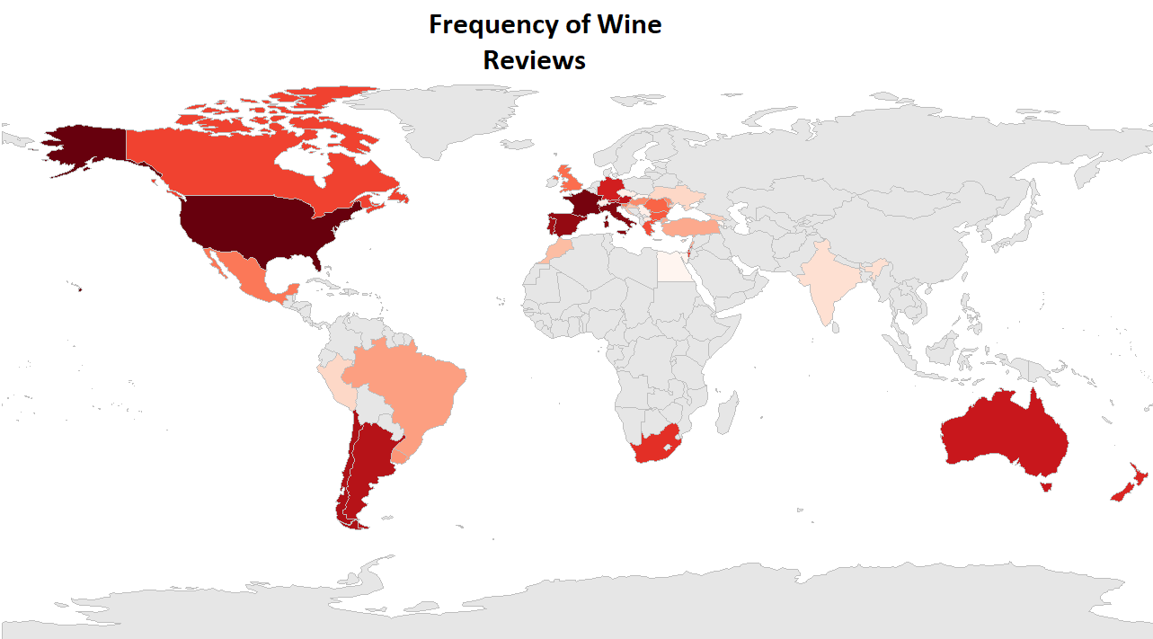
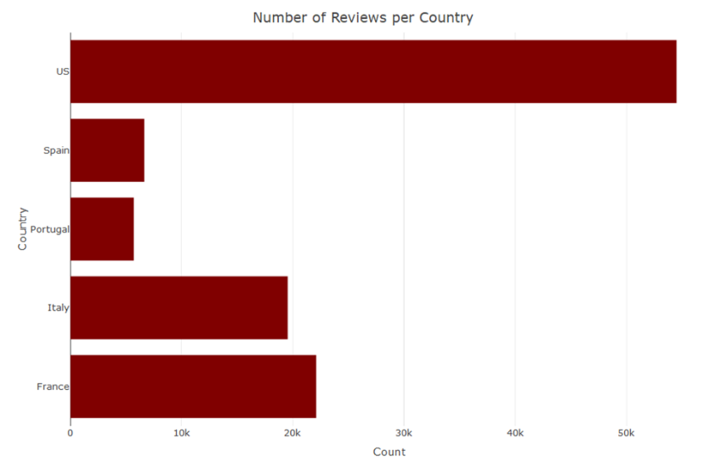
The wine reviews included wines and varieties from 42 different countries. In Figure 2 to the left, the different countries are visualized. The darker red color indicates a higher frequency of wine reviews, the lighter color indicates fewer reviews, and the gray color indicates that no reviews were provided from that country. While Europe is typically known for its wines, the United States commands the vast majority of the wine reviews. As shown in an alternate graphic provided the United States is responsible for 54,504 of the total 130,000 reviews (41.18% of the total reviews). Not surprisingly, on the list of top 5 are countries more commonly associated with wine consumption and production: France at 22,093 reviews, Italy at 19,540 reviews, Spain at 6,645 reviews, and Portugal at 5,691 reviews. While location provides more salient information regarding varieties and how wine is grown, this analysis focuses on the reviews themselves.
Figure 2 Count of wine reviews by country of wine origin
The reviews for the major wine producing countries the United States, France, and non-United States countries were isolated and frequent words were extracted (see Fig. 4). This provides an overview of the qualities and characteristics for wines within different locations. American wines seemed to be more fruit forward and cherry, wines from France seemed to be more acidic, whereas other countries seemed to be producing more aromatic wines.
Figure 3 The top 5 countries by number of wine reviews.

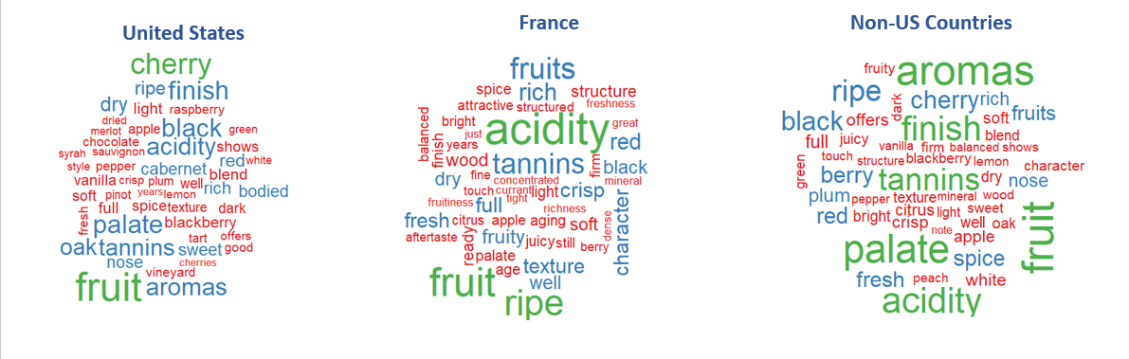
Figure 4 Most frequent words used when reviewing wines produced in US, France, and rest of world non-US countries.

The resulting summary of the dataset is shown in the following tables:
Figure 5 Summary of cleansed data

Points and Prices:
The points variable follows a standard rating scale found in Wine Spectator. While Wine Spectators review scale falls as low as 50 points, the data set examined featured more favorable wines.
Figure 6 Wine Spectator Review Ranges
The mean of the points is 88 out of a range of 80-100. There are a few wines of note that received scores of 100, they were mostly Bordeaux style red blends (35%) and 58% of those 100 scoring wines were reviewed by one reviewer – Roger Voss who will be introduced below. As shown below, most of the wines fell between 86 and 91 points which is “very good” by Wine Spectator standards. Table 3 in the appendix shows the breakdown of wine varietals and their average point breakdown. Interestingly, there does not seem to be a strong crowd favorite. Sangiovese Grosso scored the highest at 91 points on average. For lowest points at 86 there was a 5-way tie including Moscato and Prosecco.

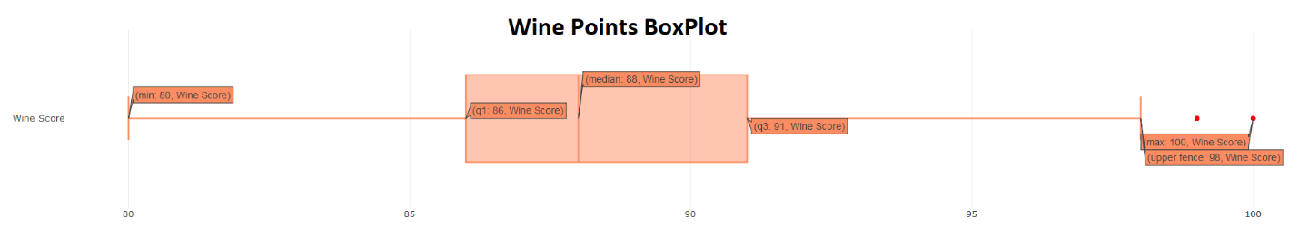
Figure 7 Boxplot of Wine Points.

It was found that prices fell across a range $4-$3,300. The mean price is $35 while the median price is $26. As seen below the mean is heavily shifted by the extreme values of the more premium wines that are in the $1,000 - $3,300 range. Amazingly, the most expensive wine on the list is not a well-aged one. It is a Tempranillo from a 2011 vintage from Covila. In fact, the top 14 most expensive wines are all from 2004 or more recent.

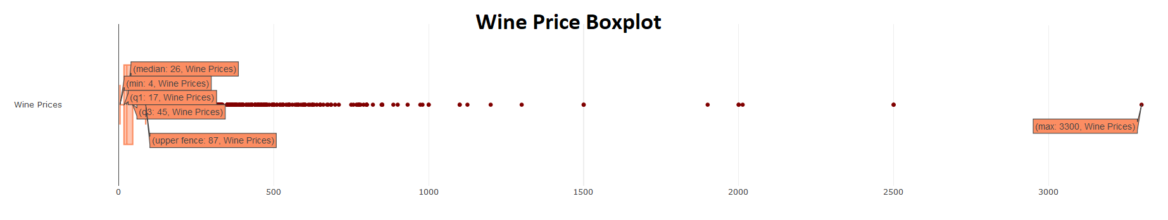
Figure 8 Wine Price Box Plot.
Min: $4 | Max: $3,300 | Median: $26 | Mean $35
Average Points per Reviewer
Taster | Avg Points
No Name | 88
Anna Lee C Iijima | 88
Carrie Dykes | 87
Fiona Adams | 87
Jim Gordon | 89
Kerin OKeefe | 89
Matt Kettmann | 90
Mike DeSimone | 89
Roger Voss | 89
Susan Kostrzewa | 86
Alexander PearTree | 86
Anne KrebiehlMW | 91
Christina Pickard | 88
Jeff Jenssen | 88
Joe Czerwinski | 89
Lauren Buzzeo | 88
Michael Schachner | 87
Paul Gregutt | 89
Sean P Sullivan | 89
Virginie Boone | 89

Reviewers:
As previously mentioned, for this analysis reviews are paramount. There were 19 unique wine tasters whose reviews were included in this analysis. Unfortunately, there were 26,244 reviews that were not associated with a reviewer, that’s about 20% of the available reviews.
Above in the point box plot, it is highlighted that there are 10 wines rated at 100 that were reviewed by Roger Voss. Although he is disproportionately represented in the 17 wines that scored 100, his overall score is in line with other reviewers. There does not seem to be an explicit bias for reviewers that needs correcting. The sidebar to the right provides another table that shows the average points assigned per each wine taster seen in the distribution table below.

Varietals & Wineries
There are 708 varieties of wine provided in the dataset from a total of 1657 wineries. The most popular wines were Pinot Noir, Chardonnay, and Cabernet Sauvignon which dominate just over 20% of the total wine reviews. Of the wineries, 200 of the wines were from Williams Selyem.

Figure 9 Top 10 Varieties and Wineries

Processing/Cleaning the data
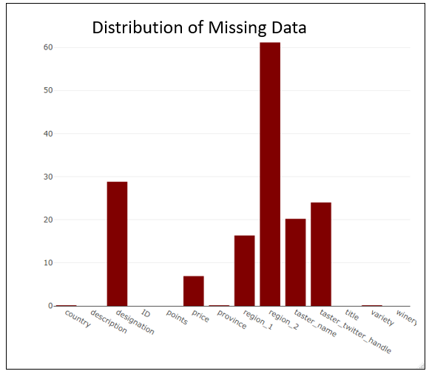
The next step in data exploration is to determine if there are missing values and to remove any unnecessary columns. The below table shows there are several columns with missing data, specifically region 2, taster twitter handle, and designation had high rates of missing values. These categories were eliminated from analysis as there was no accurate methods of imputing the data nor were the variables of interest for analysis.
Figure 10 Missing data points
The columns with high values of missing data were removed. This included the ID column, which was an artifact from the csv just indicating the row number. Retaining the row number was irrelevant to processing as the row index can be called in R; therefore, this was dropped. Additionally, the designation, which is where in the winery the grapes were grown was also removed, as it had nearly 30% of the data missing with no meaningful way to impute the data values nor was it relevant in the prediction of the varietals, therefore this column was also removed. Region 2 was missing nearly 60% of the data and like the designation, impossible to interpret and was removed. Lastly, while the twitter handle of the reviewer could provide more text analysis, for the scope of this analysis these were also dropped from consideration. Now that the meaningful rows were isolated cleansing of the data could begin.

Figure 11 Removed columns

Text Processing:
The most troubling aspect of this data set was the special characters included in the dataset. Many of the wines are from overseas and included many special characters. For example, varietal Gewürstraminer being re-written as Gewrstraminer when the umlaut was removed along with its corresponding vowel. This allowed text processing to be run without confusion of the special characters, however, the shortened term “Gewrstraminer” was used as a factor and retained its uniqueness for analytical purposes. This processing of text was run on all columns that contained text which included the reviews, the taster names, region, province, title, variety, and winery.
All numbers and punctuation were removed from the description section using the tm library in R. The description was also transformed into lower case before stop words were removed. Numbers were extracted from the title variable in order to generate the vintage of each wine.
Figure 12 Wine Terms Removed
General English stop words were removed from the dataset as well as words that were specifically related to wine, which may allow the model to cheat. Amusingly, Sauvignon was the most misspelled varietal which included nearly 15 terms to be removed. These additional wine terms were found and removed using R’s View function. Word parts were entered the search box which allowed simplistic searching of the slang terms wine reviewers have created. More sophisticated measures can be used moving forward and there are very likely terms that were missed.

Imputation:
The data contained two numeric variables, price and points. The price as noted above did have around 7% missing variables. As this number was numeric the missing values were imputed with the median. The median was selected over the mean due to the outliers in the dataset. The median of the set was $25 a bottle whereas the mean was $36, and the most expensive bottle was $3,300. Points on the other hand all managed to come over.

Duplication and NA removal:
Despite efforts, there were still NA values that were unable to be imputed such as missing reviewer names, missing varietals, and duplicate reviews. This left a data frame of 99,151 reviews.

Model specific cleansing:

Association Rule Mining
For the rule mining the descriptions and varieties were isolated into a data frame. The challenge for this data set was that the reviews were all different lengths and there was no logical way to truncate all the reviews into the same length. In order to obtain meaningful transactions from the data set two transformations took place. Spaces were removed from the varieties and turned uppercase, for example: pinot noir to PINOTNIOR. This was completed to ensure that the terms that were being isolated were in fact the varietal and not an artifact from the wine review in which the variety was referenced. Then the two rows were combined into a single string using a loop and a paste function to contain both the review and the variety within one string.
The second transformation extracted each word and assigned it a transaction number and copied it into a new data frame. The new data frame contained two columns, the transaction ID which was the number of the original review, and the word. This new data frame resulted in 2,485,499 individual words that were in all the reviews. The figure below demonstrates this transformation visually. Once the transaction set was created empty strings were removed. These empty strings were an artifact of punctuation removal. Once this was accomplished the transaction data set was complete.
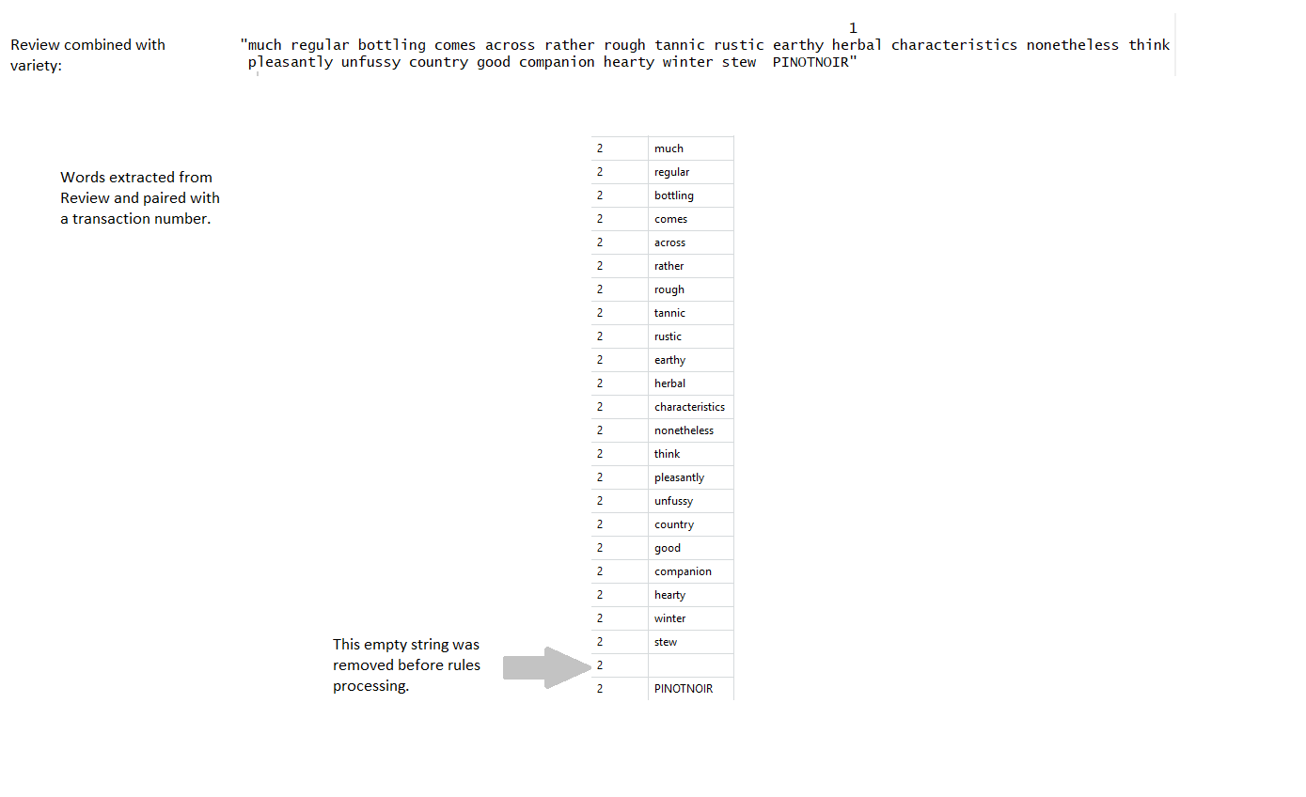
Figure 13 Transformation of Transaction Data

Modeling

Model #1: Association Rule Mining to determine if wine descriptions can predict varietal
Association rule mining was also used to discover the most commonly used words describing each type of wine. Association rule mining is a powerful data exploration tool that allows commonly occurring words be turned into “rules”. These rules can then be used for a suggestion engine or as a starting point for further analysis like a classification algorithm or a clustering algorithm.
The top 50 most frequent wines were analyzed. By identifying the main words used by wine tasters to describe specific varietals, wine distributors could better market and describe wines to various consumer groups.
Once the transaction dataset was prepared association rules were run first on Pinot Noir and Chardonnay as they were the most common wines. The variety was isolated to the right-hand side of the equation. The lift was set at 0.001 as there were many reviews and it was of interest to obtain fewer common rules that have high confidence. The confidence was set to .01 for similar reasons. It was of interest to look at the strong rules, but weak rules can also be of interest to analysis. It can show what terms not to use when describing a wine. Lastly the minimum length was set to 5. It would be overwhelming to look at 2-word pairs for a list of 2,485,499 words and their varieties. Setting the minimum length allows for 4 descriptors and 1 wine variety. This makes trends in words easier to identify.
For the large rule set, the same exploratory function was used as above, however for the righthand side of the equation all 50 varieties of wines were constrained. This means that any rule associated with a variety that has at least 4 words will show.

Model #2: K-Means Clustering
K-means is a clustering technique that identifies k number of centroids, and then allocates every data point to the nearest cluster, while keeping the distance between the cluster centroids and cluster members as small as possible.
To create the K-Means model a column was added to the data frame to differentiate between red, white, rose, and sparkling wines. Then, due to the small numbers of sparkling and roses, two subsets of only reds and whites were created. The distribution of wine types can be seen in Figure 16 below. Next, a very large matrix was created from a list of tokens created from the description feature. Then, each row was divided by the number of terms to give more weight to words where few were used. For the red and white wines, take the cross products of the matrices to get a matrix with an indication of the correlation between words. Then, divide each row by the sum of the row and apply the natural logarithm to the cross product of both the reds and the whites to get measurements. The k-means model created word clusters based on the rows which consisted of the words in the descriptions. It used a random seed generator of 100 and a k of 50. It narrowed the clusters to only those with clusters greater than 5 words and then divided the cluster variation with log size to get a measurement of how close the cluster in question was. The output described in the Results section consists of the 10 best clusters for red, and the 10 best for white.

Model #3: Decision Trees to Predict White vs Red Wines
To predict the variety of wine based on the description, Decision Tree analysis was used. A corpus and subsequently a document term matrix were created from the description column. The variety column was used as the labels for the training and testing sets.
The first model included both red and white wines from the data frame limited to the top 60 wines as discussed in the Data Exploration section. This model resulted in a very large decision tree with only 20% accuracy. The next two models, seen in the top two squares, separated out the white wine and red wine, but still collectively included all wines from the top 60 selection. These models also still had a very low (22%) accuracy, and the confusion matrix revealed that the descriptions for all wines other than chardonnay, Riesling, sauvignon blanc, pinot noir, red blend, and sauvignon did not provide enough data to make accurate predictions. The models seen in bottom two squares explored only the top 3 wines within each of the red and white wine document term matrix. The classification method was used for every instance of these decision trees.

Figure 14 Decision Tree attempts

Model #4: Decision Trees using only Adverbs and Adjectives
Understanding that Decision Tree and Naïve Bayes classifiers were achieving better results with smaller word vector-spaces, revised Decision Tree models were trained using the data from a set of adverbs and adjectives extracted from the description column. Going back to the original scope, it makes sense that a prospective diner, shopper, or sommelier would want to find a varietal using a few choice words and still get accurate results from the wine description predictive model.

Decision tree V2 preprocessing
Two data sets were used to create a DTM matrix for the decision trees. The columns used were the Variety label (the prediction) and the simplified descriptions that contained adverbs and adjectives. These words were important in categorical analysis and were therefore a likely space to investigate. The top four wines were predicted using a multi-class decision tree model -- Pinot Noir, Chardonnay, Cabernet Sauvignon, and Riesling. Hybrid blends were specifically left out, as the blend may have qualities of one wine or another, but in general, the flavor profile would be dependent on the grapes of the prior batch. Cabernet Sauvignon, and Riesling. The Variety label was joined to the AR words table using sqldf’s inner join to create a “wide,” or sparse document term matrix (DTM). a priori tuning was performed based on previous model results. Wine varietals were reduced to four wines and parameters were revised for the decision tree model. The data were then randomized and split into train and test groups, 70% and 30%, respectively. The process of growing trees with different parameter settings yielded many of the EDA results that were helpful when exploring the best ways to grow trees before pruning. During pruning, the tree X-error was used to prune the trees. Pruning was conducted by evaluating the local minima of the complexity parameter (cp), which helps understand when data partitioning has been optimized, and adding one standard deviation to that value. a posteriori tweaks were made to models and new model variants were built.

Two methods were used to evaluate the decision trees:
- Confusion matrix. A multi-class confusion matrix was used to assess accuracy.
- Receiver Operating Characteristic (ROC): ROC curves were used to assess True Positive Rate (TPR) and True Failure Rate (TFR).

For reference, a list of parameters used are included,
- Split index: information gain. Information gain is similar to GINI.
- complexity parameter (cp) = 0.03. Any split that does not decrease the overall lack of fit by a factor of cp
- bucket minimum (min_bucket) = 300: The minimum number of observations that must exist in every leaf node.
- xval: 2:5. Cross validation parameter was tested at 2,3,4, and 5 folds.
- minsplit = 200. The minimum number of observations that must exist in any node (leaf or branch)

The following parameters were tested and modeled. The final parameter configuration produced the most pleasing results and was selected to highlight.
- PARAMETERS -- Split index = information gain. complexity parameter (cp) = 0.03. Bucket minimum (min_bucket) = 300.
- PARAMETERS -- Split index = information gain. complexity parameter (cp) = 0.03. Bucket minimum (min_bucket) = 300, xval(2:5).
  - Model 10 was a replica of #9, but with cross-validation added.
- PARAMETERS -- Split index = information gain. complexity parameter (cp) = 0.002.
  - The goal of above model was to cast a wider net than the first decision tree attempt, with aggressive pruning parameters.
- PARAMETERS -- Split index = information gain. complexity parameter (cp) = 0.002. Minsplit = 200.
  - The goal of this decision model was to ensure each class was represented equally. The over-represented classes were all down sampled to match the number of Riesling wine reviews found in the training data (4685).

Model #5 Naïve Bayes:
Once again, the goal is to predict the variety of wine based on the description. And, once again, the first model was run on the entire Document Term Matrix (DTM) with very poor accuracy, so it was re-run on the subset of whites and the subset of reds.
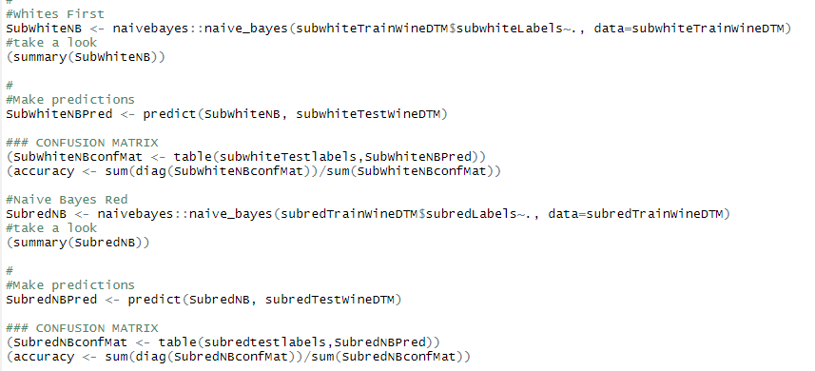
Figure 15 R Studio Output for Naive Bayes
Model #6 Support Vector Machines
After the decision trees and Naïve Bayes, it no longer made sense to keep trying to get predictions for the larger dataset, so only the subset data was used for the remaining models. For the SVM, polynomial, radial, and linear kernels were all attempted, with linear producing the best results. A cost ranging from 0 to 1000 was modeled on the linear kernel and a cost of 100 was used in the final model.
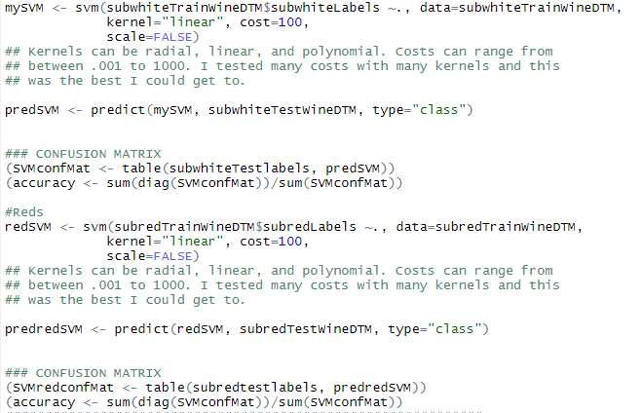
Figure 16 R Studio Output for SVM
Model #7 Random Forest
The random forest model contained 50 decision trees and was run on the subset white and subset red data.
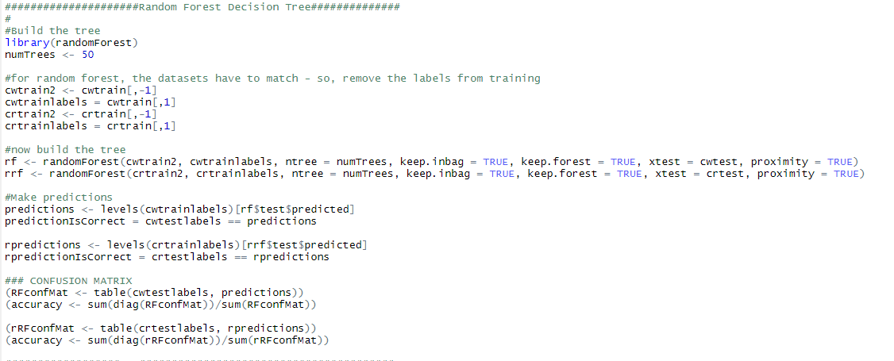
Figure 17 R Studio Output for
Model #8 K-Nearest Neighbor
KNN was run on the subset of white and the subset of red and a range from 10 – 100 used for k. Accuracy decreased above 50 and showed little change between 10 – 50, so the square root of the number of variables was used.
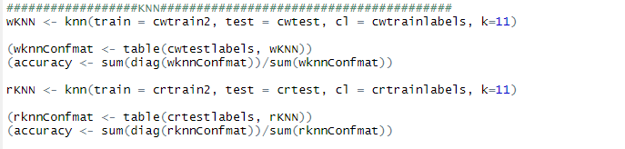
Figure 18 R Studio Output for KNN

Results

Model #1 Results: Association Rule Mining
Association rule mining provided a fundamental insight into common words that were used for each of the wine varietals. The two selected outputs were provided for example as they were the two most prolific wines. Pinot Noir shows raspberry, cranberry, and cherry as common words in the top 5 rules. This would indicate that if a client were to request a wine with cherry notes, based on the descriptions of the wine reviewers, Pinot Noir would be a safe bet. Similarly, for the Chardonnay’s buttered, toast, and pineapple are all terms a customer could use to describe a Chardonnay. While rule mining is an unsupervised training technique, it does not necessarily allow for testing for accuracy; however, the information gained from the rules can help influence future models by eliminating wines without key terms. For example, if a customer requested a oak wine, both Pinot Noir and Chardonnay may be viable recommendations, however, if the client offers the terms “oaky” and “pineapple” Pinot Noir can be eliminated as a possibility as none of the rules use that term.
Pinot Noir
Lhs | rhs | Support | confidence | lift | count
{cherry,cola,dry,silky} => | {PINOTNOIR} | 0.001022274 | 0.90833333 | 7.8881774 | 109
{bottling,cranberry,nose,palate} => | {PINOTNOIR} | 0.001153576 | 0.85416667 | 7.4177815 | 123
{cranberry,fruit,nose,palate} => | {PINOTNOIR} | 0.001041032 | 0.6686747 | 5.8069262 | 111
{cherry,fruit,oak,raspberry} => | {PINOTNOIR} | 0.001031653 | 0.58823529 | 5.1083717 | 110
{acidity,cherry,fruit,raspberry} => | {PINOTNOIR} | 0.001228605 | 0.52822581 | 4.5872354 | 131

Chardonnay
Lhs |  |  | rhs |  | support |  | confidence |  | lift | count
{buttered,oak,pineapple,toast} | => | {CHARDONNAY} |  | 0.001003517 |  | 0.96396396 |  | 9.4573664 |  | 107
{acidity,buttered,pineapple,toast} | => | {CHARDONNAY} |  | 0.001162954 |  | 0.96124031 |  | 9.4306448 |  | 124
{buttered,pineapple,toast,vanilla} | => | {CHARDONNAY} |  | 0.001209848 |  | 0.94852941 |  | 9.3059393 |  | 129
{buttered,fruit,toast,tropical} | => | {CHARDONNAY} |  | 0.001012896 |  | 0.92307692 |  | 9.0562272 |  | 108
{acidity,buttered,crisp,toast} | => | {CHARDONNAY} |  | 0.001069168 |  | 0.86363636 |  | 8.473061 |  | 114

Model #2 Results K-Means Clustering for descriptions
Using K-Means clustering provided 10 lists of words to describe the varieties of wine for both the red and white types of wines. These lists can be seen in the tables below. These lists revealed distinct types of wine, because the wines are described in specific ways. For example, descriptions for complex reds such as Cabernet Sauvignon, and Bordeaux style blends clustered together and can be seen in the Complex, Rich, and Refined columns, while descriptions of wines like Pinot Noir, which tend to be lighter and fresh clustered in columns such as Light & Fruity, Fruit Forward, and Fresh.
Figure 19 White and Red Wine descriptions Clustered by KMeans
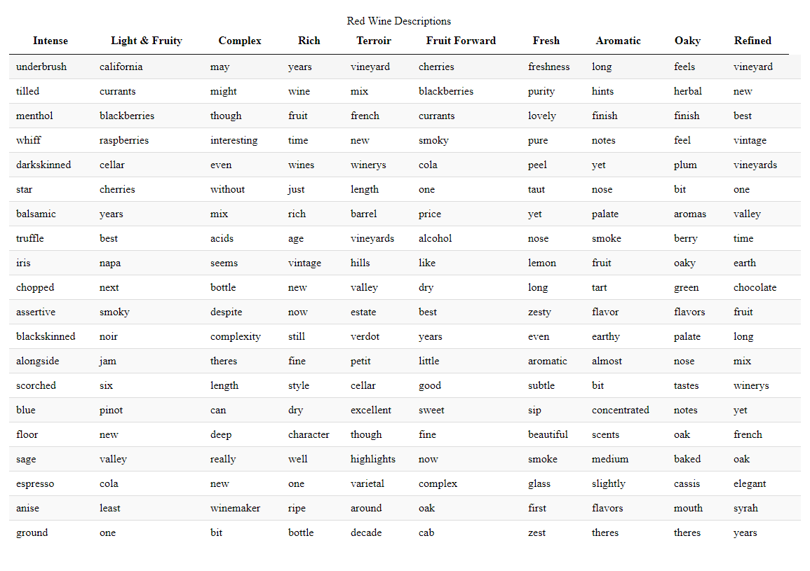
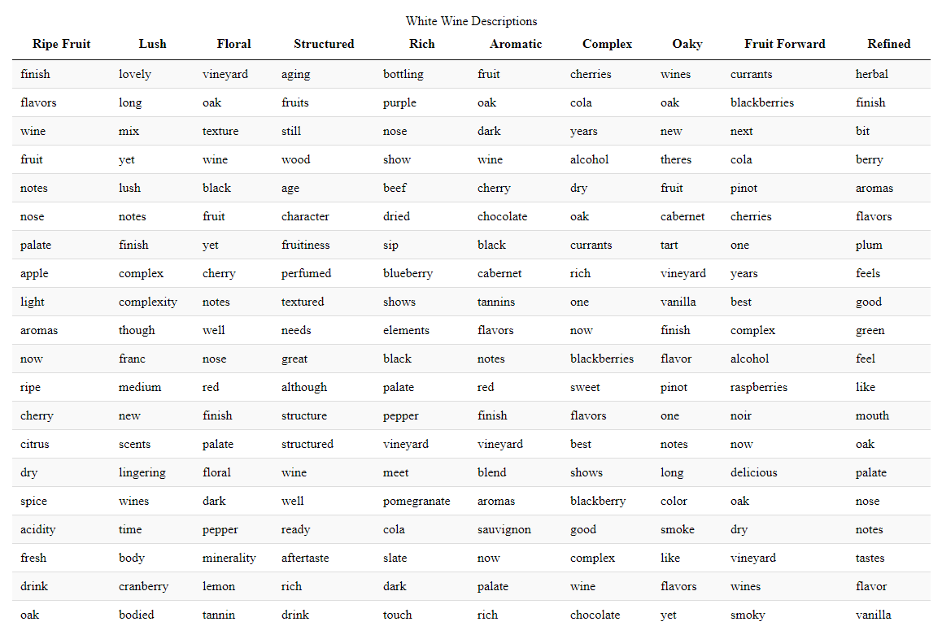
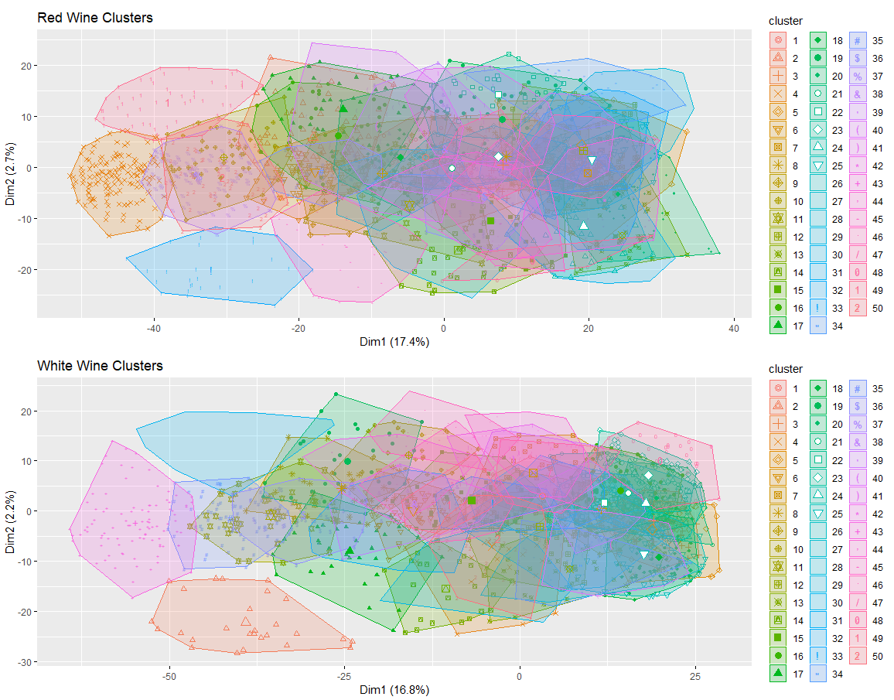
Figure 20 - Red and White Word Clusters
Model # 3 Results Decision Tree to Predict Red Vs White wines
Decision Trees
Subset White Wine: 63% Accuracy

 | Chardonnay | Riesling | Sauvignon Blanc
Chardonnay | 8525 | 477 | 313
Riesling | 2042 | 1774 | 275
Sauvignon Blanc | 2866 | 377 | 679

Subset Red Wine: 74% Accuracy

 | Pinot Noir | Red Blend | Sauvignon
Pinot Noir | 9200 | 1324 | 0
Red Blend | 3082 | 3982 | 0
Sauvignon | 95 | 147 | 0

Subset top 4 wines (2 white, 2 red): 79.7%
 | Red  (Pinot Noir, Sauvignon) | White (Riesling, Chardonnay)
Red  (Pinot Noir, Sauvignon) | 6194 | 1241
White (Riesling, Chardonnay) | 1496 | 4558

P-Value [Acc > NIR] : < 2.2e-16

Model #4 Results (accuracy: 79.1%)
An overgrown tree was produced to find the right prune point using x-error value.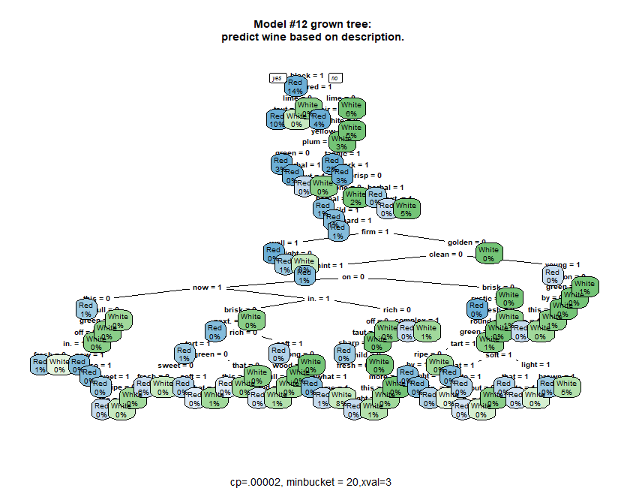
Figure 21 Unpruned tree
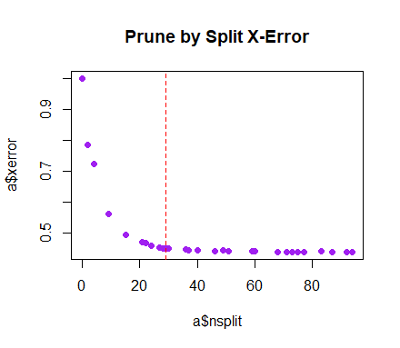
Figure 23 x-error pruning point
Figure 22 Pruned White Wine Tree

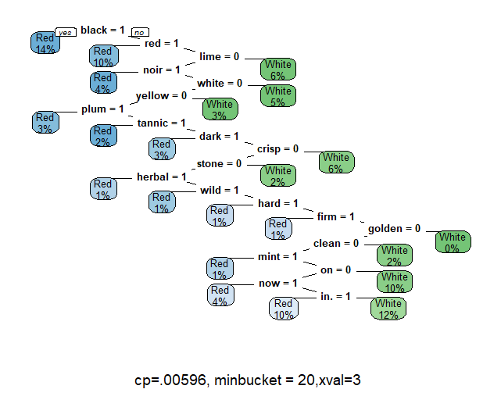
The pruned tree shows preference for the most obvious descriptors (e.g., red, yellow).

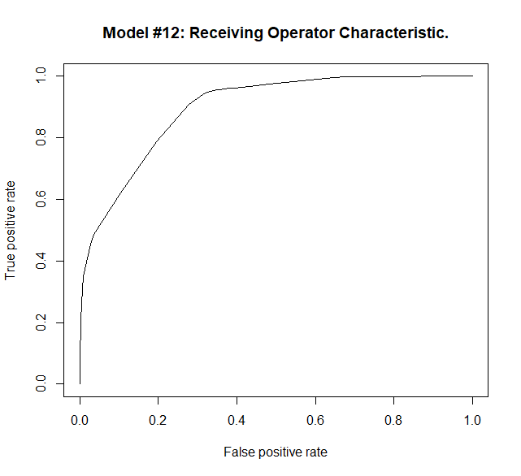
Figure 24 False positive rate vs true positive rate
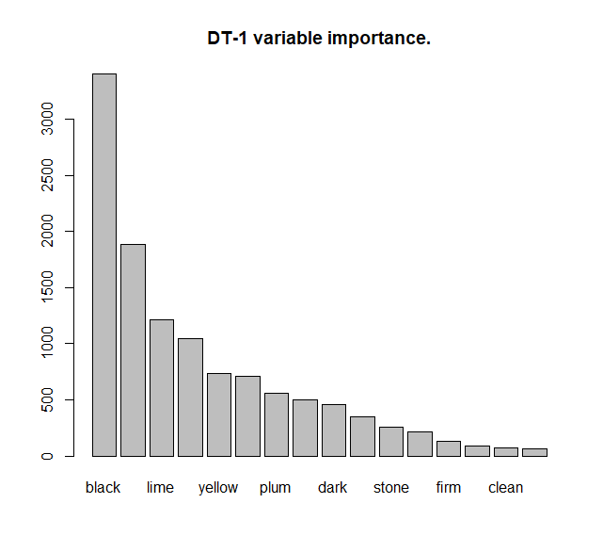
Figure 25 Feature importance by information gain

Model #5 Results: Naïve Bayes
Subset White Wine: 56% Accuracy

 | Chardonnay | Riesling | Sauvignon Blanc
Chardonnay | 4286 | 2350 | 2679
Riesling | 181 | 3394 | 516
Sauvignon Blanc | 454 | 1443 | 2025

Subset Red Wine: 1.4% Accuracy

 | Pinot Noir | Red Blend | Sauvignon
Pinot Noir | 0 | 0 | 10524
Red Blend | 0 | 0 | 7064
Sauvignon | 0 | 0 | 242

Model #6 Results: SVM
Subset White = 72%
 | Chardonnay | Riesling | Sauvignon Blanc
Chardonnay | 7844 | 623 | 848
Riesling | 881 | 2776 | 434
Sauvignon Blanc | 1758 | 387 | 1777

Subset Red = 72%
 | Pinot Noir | Red Blend | Sauvignon
Pinot Noir | 9275 | 1188 | 61
Red Blend | 1915 | 5059 | 90
Sauvignon | 64 | 48 | 130

Model # 7 Results: Random Forest
Subset White = 72%
 | Chardonnay | Riesling | Sauvignon Blanc
Chardonnay | 8199 | 471 | 645
Riesling | 1028 | 2679 | 384
Sauvignon Blanc | 1962 | 383 | 1577

Subset Red = 81%
 | Pinot Noir | Red Blend | Sauvignon
Pinot Noir | 9298 | 1223 | 3
Red Blend | 1970 | 5093 | 1
Sauvignon | 77 | 97 | 68

Model #8 Results: KNN
Subset White = 64%
 | Chardonnay | Riesling | Sauvignon Blanc
Chardonnay | 8301 | 83 | 931
Riesling | 2032 | 1166 | 893
Sauvignon Blanc | 2229 | 64 | 1629

Subset Red = 76%
 | Pinot Noir | Red Blend | Sauvignon
Pinot Noir | 8830 | 1691 | 3
Red Blend | 2408 | 4648 | 8
Sauvignon | 97 | 63 | 82

Conclusion

Based on the above analysis it is possible to use data analytic modeling techniques to predict the wine varietal based on a description. For example, “buttery, toasty”, would predict chardonnay. Modeling accuracy ranged from 64-81% and therefore, the techniques with the highest accuracies would be advised.
By predicting wine varietals, a wine distributor could reach the consumer that doesn’t already know the types of wines they would like. According to a recent study conducted for a large wine distributor, there are six types of consumers: Enthusiast, Image Seekers, Savvy Shopper, Traditionalist, Satisfied Sipper and Overwhelmed. At one end of the spectrum, the enthusiasts “are very knowledgeable and particularly passionate about the entire subject of wine. They study and explore wine’s global aspects -often sharing their discoveries with their wine drinking friends.” On the opposite end of the spectrum, the overwhelmed consumer “simply cannot deal with the wine buying experience. There are too many options on the shelves, and this creates a fretful, intimidating experience for them.” Varietal predictions could save those consumers who do not like the wine selection process a lot of angst and time.
Imagine a kiosk at the liquor store or at a table at a restaurant. The kiosk could allow for natural language entries of the description of flavors one prefers, or even the meal they would be pairing the wine with. The kiosk would return the various wine varietals that meet the description. As with all industries, technology is discovering new ways to do business and to save corporations every day – perhaps the profession of Master Sommelier, which earns on average of $US150,000 per year, will be replaced by a kiosk at a restaurant near you.

Appendix

Data Dictionary – Original Dataset
Variable Name | Description | Data Type
ID | Line item/row count | Integer
Country | The country that the wine is from | Factor w/ 44 levels
Description | Description of wine | Factor w/ 119,955 levels
Designation | The vineyard within the winery where the  grapes that made the wine are from | Factor w/ 37,977 levels
Points | The # of points wineenthusiast.com rated  the wine on a scale of 1-100 (they only  post reviews that score >=80) | Integer
Price | Price of the wine | Integer
Province | The province or state that the wine is from | Factor w/ 426 levels
Region 1 | The wine growing area in a province or  state (i.e., Napa) | Factor w/ 1,230 levels
Region 2 | Sometimes there are more specific regions specified within a wine growing area, but  this value can sometimes be blank | Factor w/ 18 levels
Taster Name | Name of person who taste tested the wine | Factor w/ 20 levels
Taster Twitter Handle | Twitter handle of tester | Factor w/ 16 levels
Title | The title of the wine review, which often  contains the vintage | Factor w/ 118,8840 levels
Variety | The type of grapes used to make the wine (i.e. Pinot Noir) | Factor w/ 708 levels
Winery | The winery that made the wine | Factor w/ 16,757 levels
Table 1 Data Dictionary

Province | Variety | Count | Province | Variety | Count
California | Pinot Noir | 6,896 | California | Cabernet Sauvignon | 5,693
California | Chardonnay | 5,183 | Bordeaux | Bordeaux Style Red Blend | 4,617
Oregon | Pinot Noir | 2,786 | Piedmont | Nebbiolo | 2,664
California | Zinfandel | 2,639 | Burgundy | Chardonnay | 2,312
Tuscany | Red Blend | 2,174 | Tuscany | Sangiovese | 2,152
California | Syrah | 1,870 | California | Sauvignon Blanc | 1,807
California | Red Blend | 1,804 | Burgundy | Pinot Noir | 1,550
California | Merlot | 1,391 | Mendoza Province | Malbec | 1,367
Washington | Cabernet Sauvignon | 1,365 | Champagne | Champagne Blend | 1,221
N. Spain | Tempranillo | 1,212 | Washington | Syrah | 1,129
Provence | Rosè | 1,062 | Mosel | Riesling | 1,011
Beaujolais | Gamay | 987 | Bordeaux | Bordeaux Style White Blend | 951
Douro | Portuguese Red | 880 | California | Bordeaux Style Red Blend | 876
Washington | Red Blend | 854 | Loire Valley | Sauvignon Blanc | 752
Tuscany | Sangiovese Grosso | 750 | Washington | Bordeaux Style Red Blend | 743
New York | Riesling | 734 | Alsace | Riesling | 718
Veneto | Glera | 704 | California | Petite Sirah | 694
Washington | Merlot | 666 | Veneto | Corvina Rondinella Molinara | 619
Washington | Chardonnay | 612 | Port | Port | 600
N. Spain | Tempranillo Blend | 558 | Veneto | Red Blend | 552
California | Sparkling Blend | 547 | Alentejano | Portuguese Red | 535
California | Rosè | 513 | N. Italy | Pinot Grigio | 513
California | Rhone Style Red | 499 | Oregon | Chardonnay | 498
Mendoza Province | Cabernet Sauvignon | 486 | Rhone Valley | Rhone Style Red Blend | 484
Piedmont | Barbera | 479 | California | Sparkling Blend | 477
Alsace | Gewürstraminer | 476 | Oregon | Pinot Gris | 474
Alsace | Pinot Gris | 458 | Marlborough | Sauvignon Blanc | 446
S. Australia | Shiraz | 443 | California | Viognier | 436
Washington | Riesling | 422 | S.W. France | Malbec | 419
Sicily Sardinia | Red Blend | 401 | California | Grenache | 373
Table 2 Breakdown of Wine varieties by Province(or State)

Variety | Points | Variety | Points | Variety | Points
Aglianico | 89 | Albarino | 88 | Barbera | 89
Blaufränkisch | 90 | Bordeaux Style Red Blend | 89 | Bordeaux Style White Blend | 89
Cabernet Franc | 88 | Cabernet Sauvignon | 89 | Carmenere | 87
Champagne  Blend | 90 | Chardonnay | 88 | Chenin Blanc | 89
Corvina  Rondinella  Molinara | 88 | Gamay | 88 | Garganega | 88
Garnacha | 86 | Gewürztraminer | 89 | Glera | 87
Grenache | 89 | Grüner Veltliner | 90 | Malbec | 88
Melon | 88 | Meritage | 88 | Merlot | 87
Montepulciano | 87 | Moscato | 86 | Mourvdre | 89
Nebbiolo | 90 | Nero d’Avola | 87 | Petit Verdot | 88
Petite Sirah | 88 | Pinot Blanc | 88 | Pinot Grigio | 86
Pinot Gris | 88 | Pinot Noir | 89 | Port | 90
Portuguese Red | 89 | Portuguese White | 87 | Primitivo | 87
Prosecco | 86 | Red Blend | 88 | Rhonestyle Red  Blend | 89
Rhone Style White Blend | 88 | Riesling | 89 | Rosè | 87
Sangiovese | 89 | Sangiovese Grosso | 91 | Sauvignon | 88
Sauvignon Blanc | 87 | Shiraz | 89 | Sparkling Blend | 88
Syrah | 89 | Tempranillo | 88 | Tempranillo Blend | 88
Torrontes | 86 | Verdejo | 88 | Vermentino | 88
Viognier | 88 | White Blend | 87 | Zinfandel | 88
Table 3 Average point rating per Wine

The top sixty varietals can be seen below. Data exploration was limited to the top sixty since wine varieties beyond that number became too small for analysis and contained unfamiliar varieties.
Varietal | Count | Varietal | Count | Varietal | Count
Pinot Noir | 13,272 | Chardonnay | 11,753 | Cabernet Sauvignon | 9,472
Red Blend | 8,946 | Bordeaux Style Red Blend | 6,915 | Riesling | 5,189
Sauvignon Blanc | 4,967 | Syrah | 4,142 | Rose | 3,564
Merlot | 3,102 | Nebbiolo | 2,804 | Zinfandel | 2,714
Sangiovese | 2,707 | Malbec | 2,652 | Portuguese Red | 2,466
White Blend | 2,370 | Sparkling Blend | 2,153 | Tempranillo | 1,810
Rhine Style Red Blend | 1,471 | Pinot Gris | 1,455 | Champagne Blend | 1,396
Cabernet Franc | 1,353 | Grüner Veltliner | 1,345 | Portuguese White | 1,159
Bordeaux Style White Blend | 1,056 | Pinot Grigio | 1,052 | Gamay | 1,025
Gewürztraminer | 1,012 | Viognier | 996 | Shiraz | 836
Petite Sirah | 770 | Sangiovese Grosso | 751 | Barbera | 721
Glera | 709 | Port | 668 | Grenache | 651
Corvina Rondinella  Molinara | 619 | Chenin Blanc | 591 | Tempranillo Blend | 588
Carmenàre | 575 | Albariño | 477 | Pinot Blanc | 442
Rhine Style White Blend | 425 | Nero d’Avola | 365 | Aglianico | 359
Moscato | 358 | Garnacha | 326 | Sauvignon | 316
Verdejo | 294 | Melon | 280 | Garganega | 270
Petit Verdot | 269 | Meritage | 260 | Torrontès | 260
Prosecco | 236 | Blaufränkisch | 232 | Vermentino | 232
Mourvedre | 229 | Primitivo | 222 | Montepulciano | 215
Table 4 Top 60 Varietals

https://en.wikipedia.org/wiki/History_of_wine
https://wine.lovetoknow.com/wiki/Who_Invented_Wine
https://www.wineinstitute.org/resources/statistics/article86
https://www.statista.com/statistics/259353/number-of-wineries-in-the-us/
https://www.winestyr.com/wine-guide/how-many-different-types-of-wine-grapes-are-there
https://www.winespectator.com/articles/scoring-scale
R&D Study conducted for a large wine distributor, which needs to remain confidential.
https://www.businessinsider.com/what-it-takes-to-become-a-master-sommelier-2015-6

